PA3CLQ's Leuke Linken Nr. 523

Goodbye K3Y! #k3y
The "Radio Lunch" illustration is from one of the old Hugo Gernsback publications, ca. 1920s.
He did indeed publish the first science-fiction magazine, I believe.
I have the magazine around here somewhere...

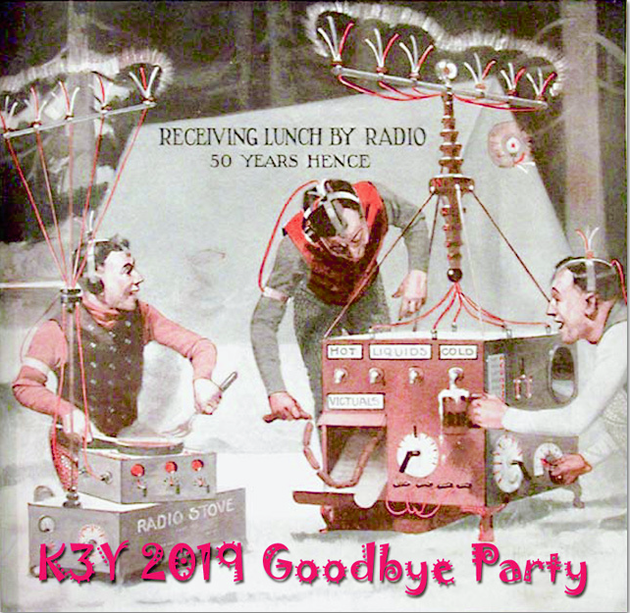

The "Radio Lunch" illustration is from one of the old Hugo Gernsback publications, ca. 1920s.
He did indeed publish the first science-fiction magazine, I believe. I have the magazine around here somewhere...
73, Drew AF2Z
Thank you, Drew.
Yes Hugo (for whom the Hugo Science Fiction awards is named) was a giant in Science Fiction and well as radio.
Amazing Stories was the first Sci-Fi mag and Radio News andThe Electrical Experimenter
https://en.wikipedia.org/wiki/The_Electrical_Experimenter
https://en.wikipedia.org/wiki/Hugo_Gernsback
has a great write up of his life for those interested.
I love the old bang-bang shoot ‘em up science fiction from the early years.
I love all of Doc Smiths work (Lensman series and Skylark of Space series.)
Leslie Hock WB5JWI
[skcc] K3Y 2019 update & wrap-up
Thanks to everyone who participated this year. It was our best ever for overall activity, if not propagation conditions.
Special thanks to our operators outside of the US. Condx were not good for DX, so a big "THANK YOU" for hanging in there!
When conditions improve, hopefully by next year, the DX activity will be much easier.
Log files are still coming in.
We will fix missing QSOs and busted calls in the master log where possible.
So, if you are missing any qsos pls contact the coordinator in your region, or let me know about it.
You can search the K3Y log here:
https://www.skccgroup.com/k3y/k3y-logsearch.php
The Stats & Op Map are still being updated as new logs come in or corrections are made.
K3Y Operators can check their stats & QSO map at these links:
https://www.skccgroup.com/k3y/k3y-statistics.php?show=stations
https://batchgeo.com/map/60b5a5d2516536655cfaf2dcc27d1095
(The Op Map will only be up for a couple of more weeks since we have to pay for it now.
If you want a screen shot, now is the time to take it.)
Callers can check their stats and sweeps at these links:
https://www.skccgroup.com/k3y/k3y-statistics.php?show=sweeps
https://www.skccgroup.com/k3y/k3y-statistics.php?show=participants
K3Y QSL cards are tentatively scheduled to go out by the end of Feb or early March.
For info see the following link:
https://www.skccgroup.com/k3y/k3y-qsl-info.php
Note that non-US members can get K3Y cards by making a PayPal payment to the bureau.
US members must supply SASE.
If any questions or problems just let your regional Coordinato or me know.
For myself, I had lots of fun this year.
I hope you did also and plan on doing it again next year.
Pls do think about being a K3Y Operator next time around; there is plenty of room for more op's.
73, Drew - AF2Z K3Y Planning Group

Europe did a good job in the 13th SKCC Anniversary Celebration January 2019
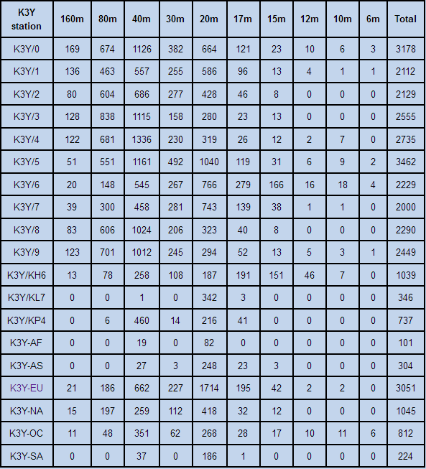
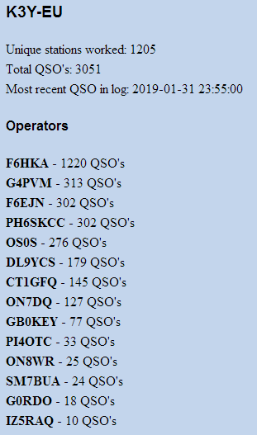

SKCC 2019 coffee mug at:
https://www.cafepress.com/mf/114672190/skcc-2019-mug_mugs?shop=SKCC&productId=430914712
Editor,,,,,,, PA3CLQ was for the 11Th time "K3Y DX Operations From the Netherlands" with PH6SKCC & PI4OTC

CWT & FOC Spot Filtering Feature
Most CW club CH files may be found here, are kept up-to-date and are tested with N1MM+:
http://www.g4bki.com/club_call_history.htm
73, Paul VP9KF

[N1MMLoggerPlus] Win10 laptop setup - stumped!
I recently picked up a couple of these and they worked without issue.
Also cheaper @ $39.98 and have attached 3' cables for each port.
https://www.amazon.com/Gearmo-Serial-Windows-Certified-Drivers/dp/B004ETDC8K
These use certified FTDI chipset, so no issues with drivers.
Chuck - N8DNX

Straight key knobs
I have been making knobs for straight keys now for a few Months now and selling them on Ebay.
The material I use is either white or black Delrin with some in combination with Aluminum. Some come with an 8-32 thread installed or even one with a 6-32 thread for a more universal fit with extra hardware.
I can do some custom knobs but there are limits to my tooling. Search ' MORSE CODE KEY KNOB' on Ebay if you may need a new knob or, just something different and to get a look at them.
Contact me directly if you need anymore info?
https://www.ebay.com/sch/i.html?_from=R40&_trksid=m570.l1313&_nkw=MORSE+CODE+KEY+KNOB%27+&_sacat=0
TNX, Jim~KK7YJ

Hello Friends
Solar cycle. Started November 2018.?
I found this interesting information on
https://www.spaceweatherlive.com/en/news/view/367/20190102-solar-cycle-25-and-the-107-cm-radio-solar-flux
"Our Sun has an 11 year cycle. The last cycle started in December 2008. Therefore many astronomers think cycle 25 will start late 2019. Some even think 2020 or as late as 2021. We found it already started in November 2018." "... we found more relationships to find the start of a new cycle. For instance the month with the lowest flux value can give as a clue, because it is close to the start of a new cycle. November 2018 had the lowest flux value till now, and therefore the new cycle can start in a time frame from October 2018 till February 2019.
More specific clues point to November 2018 as the start of solar cycle 25."
They reference this paper:
The Adjusted Solar Flux & the Start of Solar Cycle 25
https://www.researchgate.net/publication/329519943_The_Adjusted_Solar_Flux_the_Start_of_Solar_Cycle_25
In that paper, they say:
"Many solar cycle researchers think that cycle 25 will start late 2019 or even in 2020-2021. However, after analyzing the lowest adjusted 10.7cm solar flux values, we find that the adjusted flux for November 2018 is low enough to give the start of solar cycle 25 between October 2018 and February 2019, November 2018 being most likely."
(I can't resist pointing out that this result agrees exactly with the prediction from the plot of "Sideswiper Net Participation")

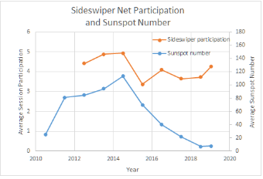
There it is.
If this is right, then things really should get better from now on.
Back last June, I'd plotted the average annual Intercontinental Sideswiper Net participation for the last few years, from Yann's archive data, as a measure of the solar activity.
This is an update, adding in the last 7 months of data.
The prediction made last June, of the bottom of the cycle being at the end of 2018, is perhaps supported, by the very slight upturn (the red line in the plot) for 2018/2019 participation. (You know what they say about statistics ...)
[Remember, David, N1EA, had a good explanation for the dip in participation in 2015.]
Just for fun.

On 6/16/2018 7:09 PM, D.J.J. Ring, Jr. wrote:
The dip in 2015 was caused by the destruction in snow storm of my 3 element beam and 50 foot tower, then my father sold his home and since I live in condo I have no antenna now. So my call no longer appears after January 26, 2015.
73, DR / David N1EA

Hello Darrel and the group,
This is very good news Darrel, thanks!
Come on good old Sol, it's time to wake up... Sunspot number curve should soon start sticking up, this should boost the QNI curve as well.
Congratulations on your plot Darrel, to be continued...
73, Yann, F5LAW.

A Small Pocket of Fast Wind: Solar Storm Shortie 02-07-2019 From Dr. Tamitha Skov
https://www.youtube.com/watch?v=IhdSNjx_yXA&feature=em-uploademail
"Although the Sun has quieted down this week , we have another chance for a solar storm coming. ..."
"... In addition, a bright region on the Earth-facing Sun has kept the solar flux up into the marginal range for radio propagation for amateur radio operators and emergency responders, but it is not a source for any big flares or radio blackouts. ..."
Cheers, Darrel, aa7fv.

Have a nice day / week(end) gents, BCNU.
Yann, F5LAW
http://www.sideswipernet.org/
By OM Yann F5LAW SideSwiperNetGroup

73, from the town at the rivers "De Bergsche Maas" and "De Dongen" Geertruidenberg (800+ years city rights) at: 51.702211N 4.853854E
Editor de PA0CLQ / PA3CLQ

Grüße von:
Jan Pieter Ulb van Ouwerkerk Armee Oelp zu Ransbach Herzogtum Nassau, Preußen Deutschland.

Its sneaks closer and closer.

-30-

E: pa3clq@casema.nl
W: www.pa3clq.nl/ i.e. Huge Direction Finding Antennas

