PA3CLQ's Leuke Linken Nr. 504

[skcc] Key loyalty. #poll
A new poll has been created:
What's the longest period of time that you have stuck with the same key for regular use; i.e., you use it pretty much every time you operate, or you keep coming back to it after trying other keys for short spells?
"Same key" refers to a particular key, not multiple keys of a particular model, type or brand that you may favor.
It could be a key that you used for a long period of time in the past but no longer use.
1. Less than 1 year.
2. 1 to 2 years.
3. 2 to 5 years.
4. 5 to 10 years.
5. More than 10 years.
Vote Now:
https://groups.io/g/SKCC/vote?pollid=2175
Drew

I'm still using my favourite, and keep going back to it, a Marconi PS No213A acquired some 30 years ago.
A wonderful pump key and this particular key is dated 1946 - my birth year HI.
A Portishead Radio "GKA" key - I score it 10/10.

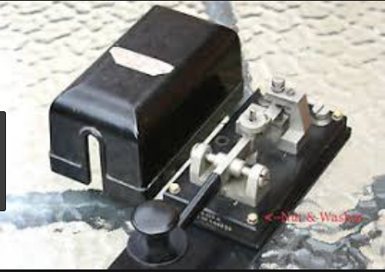
John Snell / G0RDO

I also am still using the same Nye Viking Speed-x Key with the navy knob since 1975 when I received my General ticket.
I know because I dropped the key back then and broke the larger disk and a friend of mine had some epoxy and we glued it back together and it still holding strong!
That was some tough glue back then.

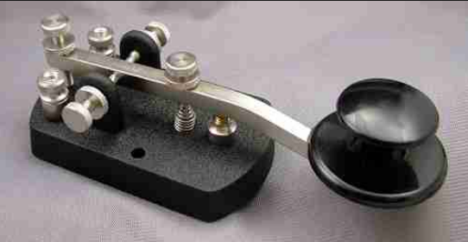

Joni Zornes

I had to choose less than a year because, well, I've been back on CW just 10 months now after a 25 year break.
But since January I have been using a Bunnell Double Speed Key I acquired, I have 3 keys usually connected at any given time but always seem to gravitate to the DSK... can't imagine at this point using anything else as my primary key.
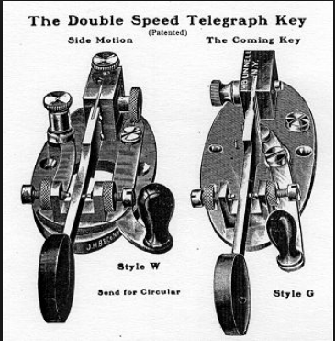

KQ4MM - Brian

Well, poll will remain open so you can come back in a year, five years and ten years to update your vote, haha...
Bunnell DSK -- what a key!
Having one of them could get me to learn how to use a sideswiper...
Drew AF2Z

Drew, in my opinion I believe the sideswiper is the easiest key of all to learn how to use.
Also in my opinion learn to form all your letters starting with either your thumb or index finger and you'll be faster and smother.
Art Searle

Lets all hope we are still around that long Drew.
ll mark my calendar to update the poll annually ..ha ha ...
Interesting poll so far, hope more comment, really fun to hear the what and why of what folks are using.
KQ4MM - Brian

I have an old J38 that I don't even remember where I got it I have had it so long.
At least 30 years. It is stamped E. F. Johnson on the frame.
I don't have it on the table rite now but sure it will get back there one of these day.
I started using a cootie about a year and a half ago.
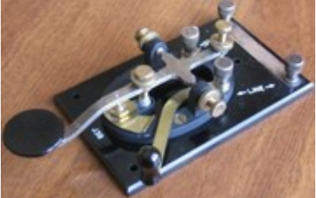

Allen KA5TJS
A new poll has been created:
Which key type do you use most on a regular basis?
Choices are limited to SKCC mechanical key types.
1. Straight key.
2. Bug or semi-automatic.
3. Sideswiper or cootie.
Vote Now: https://groups.io/g/SKCC/vote?pollid=2180
Drew AF2Z

Because of my advanced/advancing arthritis these past 25 years, I am relegated to using either a keyer/paddles or a bug.
I can still use a hand pump key but after even a short time, my fingers/knuckles are in enough pain, it would make it near impossible to use any key.
Getting old ain't fer the weak!
I do have one bug, an Olympic that was designed to be near to a paddle to use and it is a sweet key I love to use.
As I belong to/support any and all CW clubs, when I saw SKCC come into being, I decided to get back into using a bug for a couple of reasons.
One was to enjoy more CW with straight key users and other mechanical key users.
I had been away from using a bug for some 40+ years at that time, but not from CW.
I read where someone wrote, "Once a keyer operator, never a bug operator again."
I remember listening to Tate, W8FX, was hard to copy at times and he used a bug.
Someone told me, he had tried a keyer for awhile and when he came back o the bug, he was never the same.
There a couple of operators that I never know what key they are using as they sound like a machine every time, near perfect CW.
One of them and I laugh as we throw in a little Banana Boat swing or Lake Erie Chop at each other.
By the way, there is NO Lake Ere swing, it is Lake Erie Chop.
The swing comes from being hot and getting a little lazy and hanging onto the dah side a bit long Having lived in Texas or the Caribbean nearly half of my life, I do try and watch myself and not do it except as a joke very once in a rare while.
So, trying to put in a swing is not something to strive for.
Having lived the other half of my life in the Great Lake areas where it get damned cold.
I know how un-nimble ones fingers can get when they are cold.
That is when the dit side of the bug does not get released as quickly as it should and, thus, the extra dits and the sometimes shorter dahs.
Lake Erie is a relatively shallow lake and has some rather brutal waves and I have experienced them fishing.
No, I did not operate on the lakes, but I can imagine getting tossed about in the radio room during the winter on those waves until the lake froze over and having
cold fingers.
I have peered at some of these new gloves that are tight and insulated with open finger tips.
Maybe they would have helped.
One of my mentors did operate on the Great Lakes as well as the Caribbean before that.
I miss hearing him tell his stories from both places.
Back to rig and antenna work.
Maybe I can get heard this weekend during the FOC Bug Weekend.
73, Joe, K8JP/V31JP

I have had my J38 since 1960, used it as a novice and use it occasionally all these years !
Best 50 Cent investment ever !
CW is Real Radio John...K8JD

A new poll has been created:
What is your favorite straight key for everyday use?
If your favorite is not shown please post a followup and we'll add it to the poll.
Keys are listed in no particular order.
Favorite bug and sideswiper polls to follow.
1. J38
2. Junker
3. Navy Flameproof
4. Czech military key.
Vote Now: https://groups.io/g/SKCC/vote?pollid=2182
Drew AF2Z

Navy flameproof since it’s the only straight key I have.
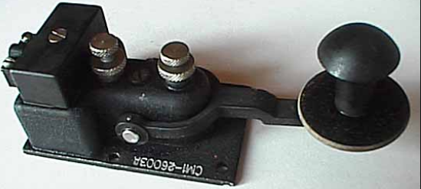
John KE6K

SpeedX with Navy knob
Wes Linscott

Ameco brass key from when I started in 1969, on a hunk of brass my dad snagged for me.
But I prefer the Speed-X with navy knob I got cheap on eBay a few years ago, with a big ugly glob of glyptol stuck to the base.
Took it apart, cleaned and repainted it, and used it in the last WES.

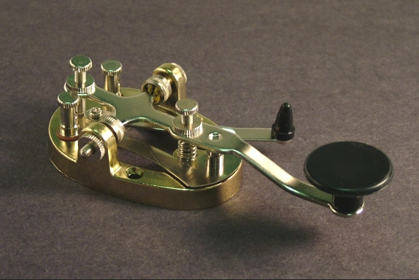
Vic VE3YT

My favorite straight key/s are the Bunnell Triumphs

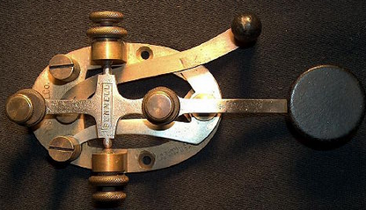
KQ4MM - Brian

My favorites
1. Begali Blade - everyday use

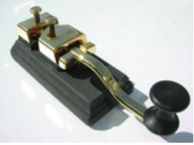
2. J38
3. Camel Back 3D printer key
Bugs and cooties later.
Greg wa3gm

The one I use the most is a Speed X
Richard K4CRD

Until it fell apart a few months ago, lost the tension spring.. my dad's old j38.. used 30 plus years
Now the Nye master key or ham key
Master key is best.
My vibroplex champion lower on the bands
Dg Arnholt Wd9dwe

I've used a lot of keys in 40 plus years but Phil Boyle, G0NVT's PB213 improved version of the Marconi PS213B key is the best
I've ever had a hand upon and I'd had the original Marconi in the past.
Beautiful key and a keeper here (and per his website, he has one available at this time).

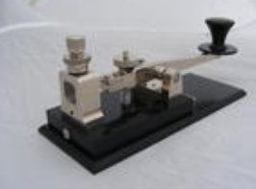

Mike, k5wmg

My ol' Nye has been with me since 1979 when I became a Ham.

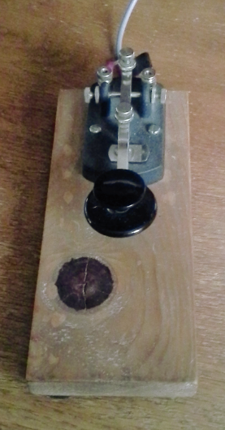

73 Art KA5DWI

Nye hand key 320-006, don't know the name.
Been using for 30 plus years.
John Paul//AB4PP

My favorites
1. SKCC Member Key by LNR (Blue Base) - best by a long shot IMHO

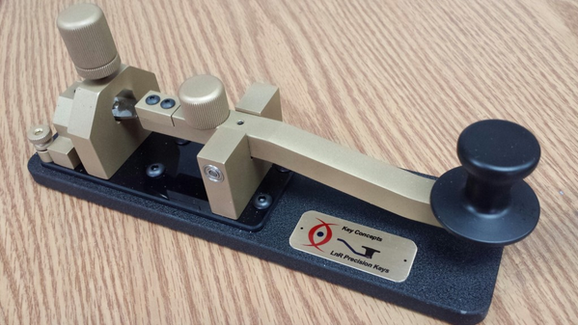
2. Nye Viking Speed-X
3. Kent KT-1
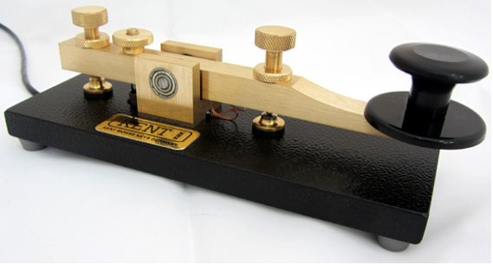

4. J-38
James Ewing

I used to use the J38 exclusively but obtained a Nye master key which is now my favorite key.
I also have a bug and several others.
Obviously, I will use the bug if I can get my speed up above 18wpm.
AG0H

Nye Viking Deluxe Speed-X. Square sides, chrome plated, silver contacts.
Been using that sucker for 42 years.
It's plugged into the rig all the time, alongside a rotating stable of bugs, cooties and autokeys.
Charles Hays

Only 3 Keys on my desk:
Amplidan

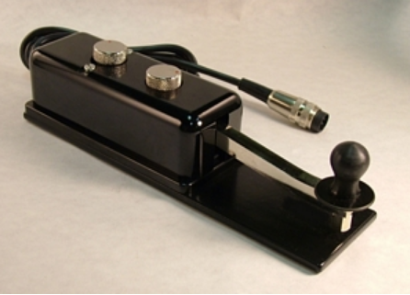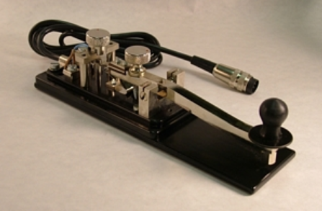
Marconi 365EZ

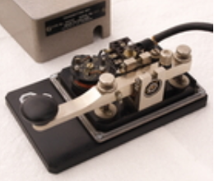
Pryce Edwards NATO key
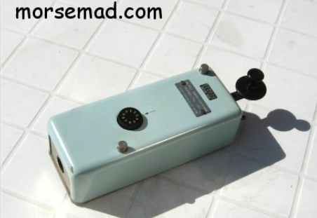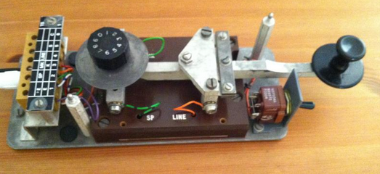

Mike AA9IL

The 213A has been with me for 40 of my 52 years operating and can only be bested (equaled) by a Marconi AS 300A. Virtually the same key.
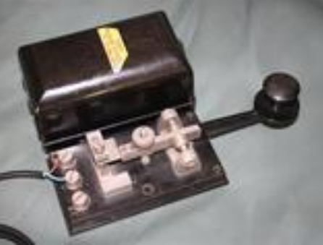

KB4QQJ

Had to rethink this.
Nye Champion hand key for more than 40 years, and my other oldie is my Vibroplex Lightning for 50 years.
I also use my N2DAN MERCURY paddles more than anything and got those in '82.
Also a E.F. Johnson Speed X Bug.
Newer paddles are Begali Sculpture and for my SOTA and QRP ops.
I have a Begali Traveler Lite.
Saw others put those on there so I thought I would share.
John Paul//AB4PP
I'll second that John.
My PS213a has been with me for 40 of my 52 years of operating.
Beats my Amplidan, NT9K Pro-Pump and a Blade.
Of course the AS 300A is pretty much the same but harder to come by.
Randy_KB4QQJ

American Morse Equipment MS2.
I built the kit and use it with the leg strap, usually portable.
I’m a new CW op though, only 7 QSOs so far, but hopefully many more soon.
Cliff Clark

My favorite Straight key is the Nye Viking.
David WD6AJR

Never had the pleasure of using a real 213 (if anyone has one to part with, let me know).
However, I've got a 213 replica by I1QOD as well as your wonderful spin on it, and both are the cream of the current crop.
NW6V

My favourite straight key isn't on that list.
It's the Begali Spark.
I have russian and czech keys, but the Spark is 1000x better.
73 de HB9FXW

My favorits is Begali Spark and Begali Intrepid.

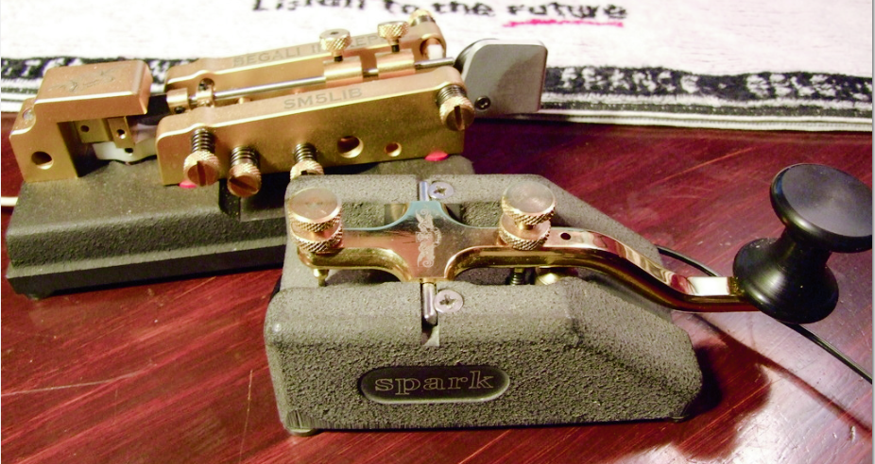

Ingemar

I voted Navy Flameproof. My other straight key is a J-38.
Robert KG4KGL

My Vibroplex Delux, circa 1972.
I always associated a bug with ham and shipboard radio ops.
I haven't always been good with it (I'm not 100% sure I am even now) but I love the feel and nostalgia of the bug.
Second choice is my Kent key modeled after the Titanic key.
I learned on a J38 and still have several but I use them only occasionally.
My go to for QRS is the German navy Junkers flameproof.
I have a Czech flameproof that I use on my tube rigs as the contacts are covered.
As a novice I touched the terminals of my HT-40 and I got a bit of a shock.
I was young and just did not know any better.
I learned but now that I older I prefer to have the key covered on my old novice rig.
Lesly Hock.

My favorite straight key, by far, is my Junker … what an amazing piece of engineering and machinery!
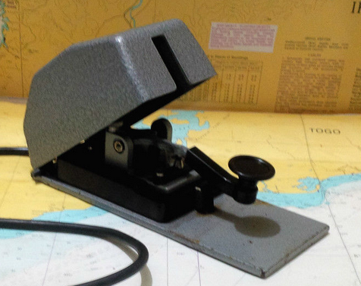

Stephen King

Hear, hear! Or is that "hoert, hoert!"
Sorry, can't locate an umlaut on my phone's keyboard at the moment.
Pete Spotts
Or hört hört.
Editor
Junker only has 3 votes but I know there are more Junker users out there...
You can see results or vote in this poll or others at the following link:
https://groups.io/g/SKCC/search?q=%23poll&ct=1
73, Drew AF2Z

My favorite straight key is my Navy Flameproof I purchased from NOS=New Old Stock on the J.H. Bunnell Company website,,,,
a few years ago while they still had a few of them left.
My Czech UV-3R straight key I picked up from W4KRN Karen, at the 2013 Dayton Hamvention comes in at a close second place.
Cliff, KU4GW

I too purchased a new, in box Navy Flameproof,,,,
and can't picture any other sk being any better and I've had most of the greatest hits except for pump key of any kind.
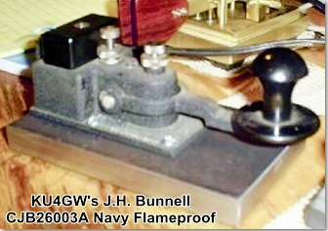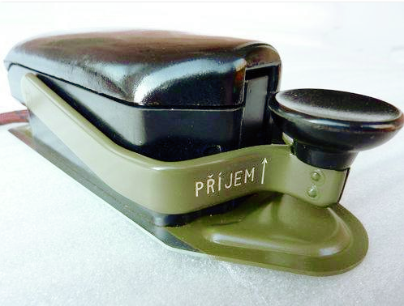

Steve, W1SFR
I like my Navy flameproof, but if I could get my Speed-X straight key from my novice days I’d jump on it in a minute.
Probably trying to get my youth back.
John KE6K

I switch off from a vast assortment of keys but I gravitate toward my Vibroplex straight Key.
My “clunking” Kent and Ham Key tie for the number 2 slot with the Junker taking 3rd!
Ken - N8KR

Glad to read “clunking” Kent!
I thought I was just doing something wrong; even on a computer mouse pad the Kent does seem to clunk!
I like mine but my shack is next to the bedroom and when my wife is sleeping only the Czech and Junker flame proofs are quiet enough not to cause issues.
Good to know it isn’t just me!
Leslie Hock WB5JWI

The clunking Kent is handy when using an old BA rigs without a sidetone.
I've got landline sounders that are not as loud.
Emil WD4SCZ

This my navy key.
It was given to me by the former owner (a ham, now SK) of a House we use to own.
This is exactly how he gave it to me, even the two scraps of black electrical tape on the board.
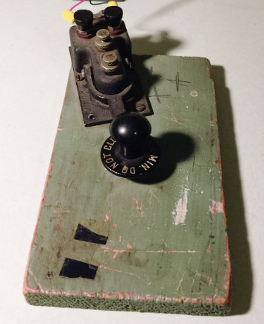

Robert S Jenkins

Ha,ha... classic no-frills ham setup.
A lot of "provenance" in that key base!
Drew AF2Z

Yes, the minimalist approach.
My main radio, an Omni V is off being repaired.
The key belonged to Richard Tollison K4NSI (SK).
I found a 1963 vanity plate with his Call sign.

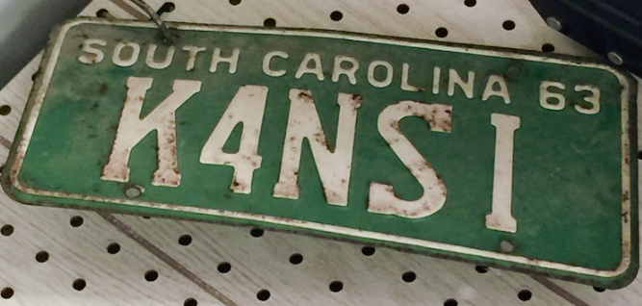
Robert S Jenkins
My daily use key is a Begali HST Mk3.

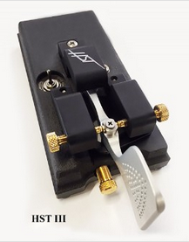
My favorite key for portable and mobile use is an American Morse Bushwacker.

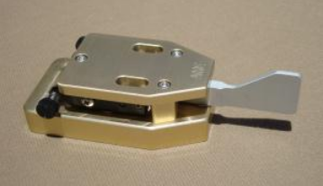
100% cootie user.
Dave, NI9M
I cannot believe that no one has mention the Begali Sculpture Swing, the best cootie key ever . . . IMO.

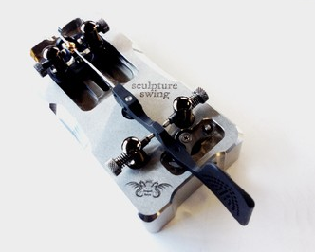

73 Art W2NRA

I'm with ART.
The Begali Sculpture Swing is undoubtedly the Rolls Royce of sideswiper keys, albeit I have personally become more adept with the Torsion Bar designs offered by W1SFR.
Anyone looking to be a proud owner of a pristine Begali Sculpture Swing, please contact me.
Maybe I missed something here in this thread as I keep waiting for the advertised poll for Sideswipers (a.k.a. cootie keys), as that is exclusively my key of choice as witnessed by 7 (count them) seven cooties here in the shack.
Since cooties are not straight keys, then I've not participated in this poll.
If I missed the opportunity to respond to a cootie survey, someone please point me to it. In the meantime, I respectfully remind all cootie users to please visit the link at my QRZ page which points to our SKCC Cootie User list which as of last count shows a total of 113.
Mike, K5MP

No, Mike - you haven't missed it.
We'll add favorite sideswiper and favorite bug soon.
Drew AF2Z
Hmm?
I have yet to find a bug I can't tune/adjust/mod to play nicely, but I will have to think about which ones I might consider to be a favourite.
Note the smoke curling about my glasses bows as i
think about that, Drew.
Joe V31JP

This poll was for favorite straight key only.
We'll do favorite bug and favorite sideswiper keys separately, yet to come.
All polls are available here:
https://groups.io/g/SKCC/search?q=%23poll&ct=1
Polls are open forever so they are really more of an ongoing survey.
You can view results, vote or change your vote at any time.
Also, "favorite" keys are ones actually owned and used.
The cost of high-end keys probably limits their popularity somewhat.
A Begali might well score higher on the "most desired" key survey that was suggested by Vic VE3YT.
We'll add that poll later.
Drew AF2Z
My J38 is at the top of the list
CW is Real Radio
John...K8JD

Love my Begali HST (pre-mark)
Alternate selection is an E.F. Johnson Speedex.
Bill w7kxb

It amuses me sometimes when I see someone post either here on this email list or on the Facebook page how that they have just bought a new straight key, and then someone else will respond with something like, "I can't wait to hear it".
To me it has much more to do with the sender's fist, not the particular key he is using.
Someone could buy the most expensive key out there and still sound terrible, while on the other hand someone else could be using the cheap plastic key previously sold by Radio Shack and sound wonderful.
Wes W1LIC

A poll has been updated:
What straight key would you most like to acquire for everyday use.
It could be a key you have owned or used in the past.
If your choice is not on the list please post a followup and we'll add it to the poll.
(Keys are listed in the same order as they appear in the "Favorite Straight Key" poll.)
1. J38
2. Junker
3. Navy Flameproof
4. Czech Military Key RM-31
5. Bunnell Triumph
6. Begali Blade
7. Nye Master Key
8. Nye Speed-X
9. Ham Key
10. G0NVT PB213
11. LNR SKCC
12. Kent KT-1
13. Amplidan
14. Marconi 365EZ
15. Pryce Edwards NATO
16. Marconi PS no 213A
17. I1QOD Marconi 213
18. Begali Spark
19. "Japan Ball Bearing Key" (Radio Shack; Lafayette)
20. Vibroplex "HK"
21. Begali Arrow
Vote Now:
https://groups.io/g/SKCC/vote?pollid=2192

Well I don't see "Homebrew" listed as a choice.
I have seven keys connected at a time and all operate, sometimes switching keys in words or characters in a QSO.
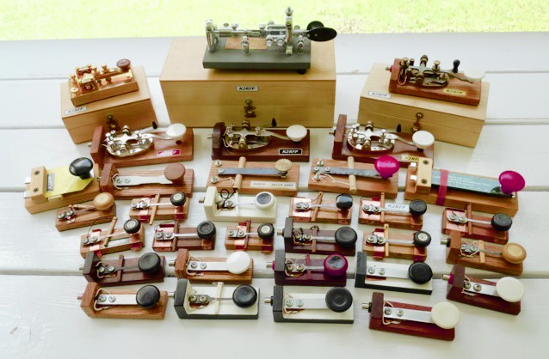

Dick. k2rfp
A long time ago, the skcc was not born yet, I used also a mouse upside down and a dih dah keyer.
Its not a Straight Key not a Cootie and not a BUG, but it works!

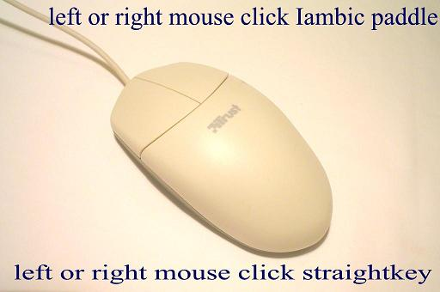

Three thimbles with wires for a squeezer function made in 2003

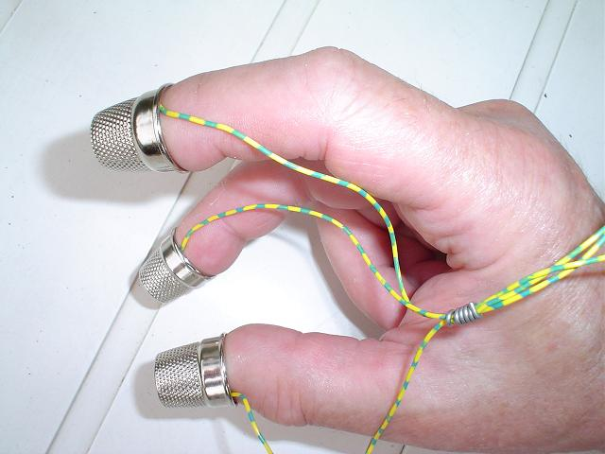

Below is difficult to handle, I really do not know how to do that?

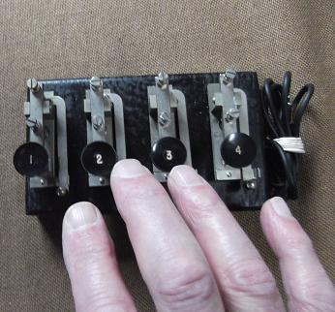
Editor

Found in several texts at the end of an assertion the following "secret" signs
B>} :D B>) ;-) ...) >!!?]
Editor

I am sorry not to be able answering to this poll,
Why ?
As a key collector, I like all my keys (more than 110 now), even if they are not very efficent but they are all sometimes used during a year for almost one contact permitting them to be alive one more time.
About SKCC event activities I am generally using following keys :
Vibroplex Original bug key, rated for 13 wpm speed,
Lionel J36 bug key for 15 wpm,
Speed-X bug key for 17 wpm, and...
a NATO straight key for very slow speeds when needed, as I always be glad to help a CW newcomer.
I choosed it because it is the larger key I have on my key collection.
All the best to all readers,
See you soon on the air,
73 de Bernard, F5DE,
110 hé
Editor
I would like to tell you which key's my radio friend Jan PA3EGH thinks is the best key.
But I do not know.
I also do not know if Jan knows?
Ask Jan PA3EGH j.v.ooijen@xs4all.nl

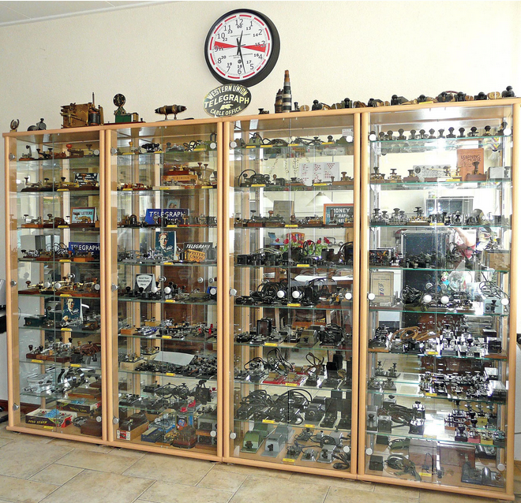

See, his showcases and more at:
https://www.pa3egh.nl/telegraphy/
Editor.

Bernard,
The "Most Wanted" poll is for some key you DON'T have but would like to acquire.
Is there no straight key that you'd like to obtain?
(Besides the one at 41/43/35N, 49/56/54W
Drew AF2Z

Here

41 43 35N 49 56 54W
Editor

Oh please excuse me for error Drew !
I thought I was answering to the "Favorite Straight Key Poll".
I did not pay enought attention that I answered by error to the "Most Wanted Straight Key Poll".
Sorry for mistake !
Best 73 to you Drew and the group,
Bernard, F5DE,
Bernard,
The important thing now is to get a rig for every key you have!
That way they are all hooked up and ready to go on the air!
I am jealous of your collection and bow in the presence of a great collector.
My compliments, sir.
Leslie Hock WB5JWI
I'd like to order one if you don't make them.
John

Hello Friends
The latest from Dr. Tamitha Skov.
A Coronal Hole in the Earth-Strike Zone: Solar Storm Forecast 07-19-2018
https://www.youtube.com/watch?v=ut2MlfmRa70&feature=em-uploademail
"... Despite three weeks of a spotless Sun, solar flux has remained at marginal levels for amateur radio propagation. However, it will begin to dip this week as one of two bright regions facing Earth rotates to the Sun's backside...."
Cheers, Darrel, aa7fv.
Have a nice day / week(end) gents, BCNU.
73, Yann, F5LAW
http://www.sideswipernet.org/
By OM Yann F5LAW SideSwiperNetGroup

73, from the town at the rivers "De Bergsche Maas" and "De Dongen" Geertruidenberg (800+ years city rights) at: 51.702211N 4.853854E
Editor Jan Pieter Oelp PA3CLQ

-30-

pa3clq@casema.nl
My simple website about Gigantic DF-Antennas
Part 1 "DF-Antenna Wullenweber Array"
Part 2 "DF-Antenna USSR Variants"
Part 3 "DF-Antenna USA Variant"
Next Part 4 "USSR OTHRA DUGA 1,2 & 3" at:
www.pa3clq.nl/

